INTERNSHIP COMPLETION REPORT
Client Acquisition & Investment Advisory Strategy
for Retail Investors
Anand Rathi Share And Stock Brokers Ltd, Indore



Prepared by: Priyal Gupta

Table of Contents
1. Executive Summary
2. About Anand Rathi Wealth
3. Project Background
4. Project Objectives
5. Work Performed During Internship
6. Methodology
7. Analysis & Key Insights
8. Key Learnings
9. Recommendations
10. Conclusion
11. Appendix

1. Executive Summary
This report summarises a seven-week internship completed with Anand Rathi Wealth Management, Indore, under the project title "Client Acquisition & Investment Advisory Strategy for Retail Investors." The internship ran from 4 June 2026 to 19 July 2026 and was structured around three phases: product and process training, field-based lead generation, and telephonic client outreach (cold calling) leading into investment advisory conversations.
The objective of the internship was to gain hands-on exposure to how a wealth management firm acquires and advises retail and mass-affluent clients - starting from product knowledge, through prospecting and lead generation, to the actual advisory conversation and conversion. Over the course of the internship, 8 days were spent in structured training (SIP, mutual funds, insurance products, equity market basics, and client risk profiling), 15 days in field visits across corporate offices and business hubs in Indore, and 14 days in outbound cold calling.
In total, 688 outbound calls were made and 9 client meetings were fixed, of which 2 progressed to a confirmed investment (SIP - Equity Fund) during the internship window. While the number of hard conversions is modest - as is typical for a short internship engagement rather than a live advisory mandate - the internship generated a meaningful, reusable pipeline of leads across multiple corporate locations in Indore, and produced first-hand observations on retail investor behaviour, objection patterns, and the relative effectiveness of field visits versus cold calling as acquisition channels.
Key outcomes of the internship include: (a) a working understanding of the end-to-end client acquisition funnel used in retail wealth advisory, (b) practical exposure to SIP, mutual fund, and insurance product positioning, (c) a data-backed view of which activities (field visits vs. cold calls) yield better meeting conversion, and (d) a set of actionable recommendations - detailed in Section 9 - to improve lead quality and conversion efficiency for future acquisition drives run out of the Indore branch.
This report is organised to first establish context on Anand Rathi Wealth and the business problem, then walk through the work performed, the methodology followed, the analysis of results, and finally the learnings and recommendations arising from the internship.

2. About Anand Rathi Wealth

2.1 Company Overview
Anand Rathi Wealth Limited is an NSE-listed wealth management company that has been in the private wealth business since 2002, serving High-Net-Worth Individuals (HNIs) and Ultra-High-Net-Worth Individuals (UHNIs) as its core private wealth clientele, alongside a broader retail and mass-affluent base serviced through its distribution and digital wealth channels. The firm is registered with AMFI as a mutual fund distributor and operates through a network of Relationship Managers across major Indian cities, complemented by a representative presence for the NRI segment.
The company's positioning is built around structured, research-backed, goal-based advisory rather than transaction-led selling - a philosophy that was visible throughout the training modules covered during this internship, particularly in the emphasis on risk profiling before product recommendation.

2.2 Wealth Management Business Model
Anand Rathi Wealth's business model spans three broad pillars: (1) Private Wealth advisory for HNI/UHNI clients, delivered through dedicated Relationship Managers; (2) a digital and retail-facing wealth proposition that extends structured investment products - primarily mutual funds via SIP/lump-sum, and allied insurance solutions - to a wider mass-affluent and retail investor base; and (3) a technology platform (Omni Financial Advisor) that supports independent financial advisors and mutual fund distributors with client reporting, transaction execution, and business dashboards.
Revenue is earned primarily through distribution commissions on mutual funds and insurance, advisory fees, and platform fees - which makes client acquisition and long-term client retention (via SIP persistency) central to the business, rather than one-off transaction volume.

2.3 Services Offered
- Mutual fund distribution across equity, debt, hybrid, and ELSS (tax-saving) categories
- Systematic Investment Plans (SIPs) for disciplined, long-term wealth creation
- Life insurance distribution (partnerships including Manipal Life, HDFC Life, ICICI Prudential, and Tata AIA)
- Goal-based financial planning and client risk profiling
- Portfolio review and rebalancing advisory for existing clients
- Digital wealth tools and reporting through the Omni Financial Advisor platform

2.4 The Retail Investor Segment
Within the branch network, the retail and emerging-affluent segment - typically salaried professionals and small business owners investing through SIPs - represents the volume layer of client acquisition that feeds the advisory pipeline. This internship was scoped specifically around this segment: identifying working professionals at corporate offices and business hubs in Indore, introducing them to SIP and insurance products, and converting interested prospects into advisory meetings.

3. Project Background

3.1 The Business Problem
Retail and mass-affluent client acquisition is a volume-and-trust business: prospects rarely commit to an investment on first contact, awareness of products such as SIPs and ELSS funds is uneven, and financial advisors compete for attention against banks, direct mutual fund platforms, and informal advice from friends or family. For a branch such as Indore, the core acquisition problem is less about product availability and more about generating a consistent, high-quality pipeline of prospects and converting a reasonable share of them into meetings and, eventually, investors.

3.2 Why Client Acquisition Matters
For a wealth management firm whose revenue is tied to assets under management and SIP persistency, every new retail client added today compounds into recurring revenue and, over time, potential upgrades into the HNI advisory book. Client acquisition is therefore not a one-off sales function but the entry point into a long-term advisory relationship. A structured, repeatable acquisition process - rather than ad hoc selling - is what allows a branch to scale its client base predictably.

3.3 Role of Investment Advisory in Wealth Management
Investment advisory sits downstream of acquisition: once a prospect is engaged, the quality of the advisory conversation - correctly profiling the client's risk appetite, time horizon, and goals before recommending a SIP category or insurance product - determines both conversion and long-term retention. During this internship, training on risk profiling and client-need assessment (Section 6) was directly applied during field visits and cold-calling conversations, linking the acquisition and advisory functions in practice rather than treating them as separate silos.

4. Project Objectives
The objectives below were defined at the start of the internship and align with the actual work carried out over the seven-week period:
- Build a working knowledge of core retail investment products - SIPs, mutual fund categories, and life insurance - sufficient to explain and position them to a prospective client.
- Generate retail investor leads through structured field visits to corporate offices and business hubs across Indore.
- Convert generated leads into advisory meetings through outbound (cold-calling) follow-up.
- Apply client risk-profiling and need-assessment techniques learned in training to real prospect conversations.
- Track and analyse daily acquisition activity (calls made, meetings fixed, conversions) to identify which channels and pitches worked best.
- Translate field observations into practical recommendations for improving the branch's client acquisition process.

5. Work Performed During Internship

5.1 Overview of Daily Responsibilities
Work was organised into three sequential phases over the 46-calendar-day internship period (46 calendar days, of which 9 were company-designated off days - Sundays and the 2nd Saturday of each month), summarised below.
Activity Type | Days | Share of Internship | Primary Output
Training | 8 | 17% | Product & process knowledge (SIP, MF, Insurance, Equity basics, Risk profiling)
Field Visit | 15 | 33% | Lead generation at corporate offices / business hubs
Cold Calling | 14 | 30% | Outbound follow-up, meetings fixed, conversions
Off Days | 9 | 20% | Sundays + 2nd Saturday (per company policy)
Table 1: Distribution of internship days by activity type
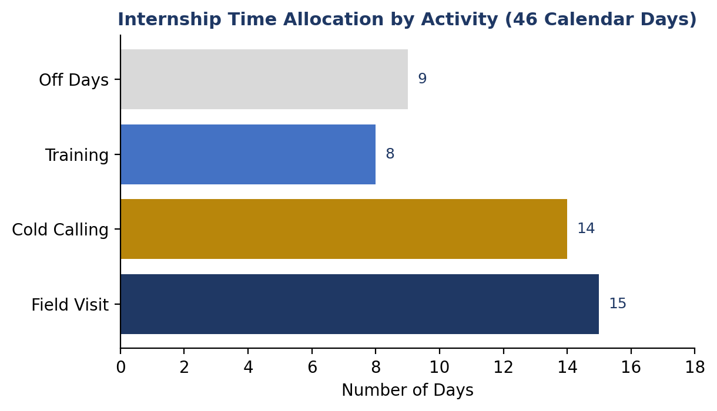
Figure 1: Time allocation across the internship (46 calendar days)

5.2 Training Phase (Week 1-2)
The first eight working days were dedicated to structured training, covering: company induction and an overview of the financial services industry; SIP mechanics and the power of compounding; mutual fund categories (equity, debt, hybrid, ELSS) and their risk-return profiles; life insurance products across three partner insurers (Manipal Life, HDFC Life & ICICI Prudential, Tata AIA) including plan types, premium structures, and riders; equity market basics (indices, demat and trading accounts); and finally, client risk-profiling and need-assessment techniques. This training directly fed into the pitches used during subsequent field visits and cold calls.

5.3 Client Acquisition Activities - Field Visits
Fifteen field-visit days were carried out across eight distinct corporate/business locations in Indore - MG Road Corporate Park, Vijay Nagar Business Hub, Race Course Road, AB Road commercial complex, Bhawarkuan business district, Scheme 54 office towers, Sapna Sangeeta corporate lane, and Palasia commercial hub - with each location revisited once over the internship as part of a rotating coverage plan. Activities at each location included door-to-door introductions to office HR/admin teams, short SIP-awareness talks, brochure distribution, and collection of contact details for follow-up.

5.4 Client Acquisition Activities - Cold Calling
Fourteen days were dedicated to outbound cold calling of leads generated from field visits, averaging approximately 49 calls per calling day (688 calls across 14 days). Calls followed a consistent structure: introducing the SIP/mutual fund or insurance product relevant to that day's leads, briefly explaining benefits, and attempting to fix a follow-up meeting. Of the 9 total meetings fixed during the internship, 7 originated from cold-calling days and 2 from same-day field-visit conversations.

5.5 Client Profiling & Investment Discussions
Where a prospect showed interest, the training-phase risk-profiling framework was applied informally on calls - understanding whether the prospect was looking at short-term liquidity, tax-saving, or long-term wealth creation - before positioning a specific SIP category (Equity, Hybrid, Debt, or ELSS) or an insurance plan. Two prospects converted into confirmed clients during the internship window (Section 7 has details); a further set of leads remained in follow-up status at the close of the internship.

5.6 Market Research
Several field-visit days were explicitly framed around market research - assessing footfall, employee profile, and receptiveness at a given business location - to inform which locations were worth a second visit and which pitch (SIP vs. insurance-led) tended to land better with that audience.

5.7 Team Collaboration
Daily activity (calls made, meetings fixed, remarks/status) was logged and shared with the reporting manager, enabling course correction - for example, shifting from a single generic pitch to product-specific pitches (Equity SIP, Hybrid Fund SIP, ELSS Tax-saving SIP, Debt Fund SIP) rotated across calling days once early feedback showed generic pitches underperformed.

6. Methodology

6.1 Process Followed
The internship followed a linear acquisition funnel: Training -> Field Visit (lead generation) -> Cold Calling (follow-up & meeting-fixing) -> Advisory Conversation -> Conversion. Each field-visit day's leads were queued for cold-calling follow-up within the same week, keeping the gap between first contact and outreach short.

6.2 Data Sources
All activity was self-logged on a day-wise basis: date, day type, task/activity performed, number of calls made, number of meetings fixed, and remarks/status. This day-wise log is the primary data source for the analysis in Section 7. Client conversion details (name, company, product, and status) were separately recorded once an investment was confirmed.

6.3 Analytical Approach
Daily entries were aggregated by activity type (Training / Field Visit / Cold Calling / Off) and by week to identify volume trends, and a simple funnel view (Calls Made -> Meetings Fixed -> Conversions) was used to assess overall conversion efficiency. Given the internship's short duration, this is intended as a directional read on process effectiveness rather than a statistically robust sample.

7. Analysis & Key Insights

7.1 Client Acquisition Funnel
Across the internship, 688 outbound calls converted into 9 meetings (a 1.3% call-to-meeting rate), and 9 meetings converted into 2 confirmed clients (a 22.2% meeting-to-conversion rate). This pattern is consistent with typical outbound retail acquisition benchmarks, where the call-to-meeting step is the volume bottleneck, while a fixed meeting - by the time a prospect agrees to sit down - already carries a meaningfully higher chance of converting.
Stage | Volume | Conversion to Next Stage
Calls Made | 688 | 1.3% (9 meetings)
Meetings Fixed | 9 | 22.2% (2 conversions)
Clients Converted | 2 | -
Table 2: Acquisition funnel - calls to meetings to conversions
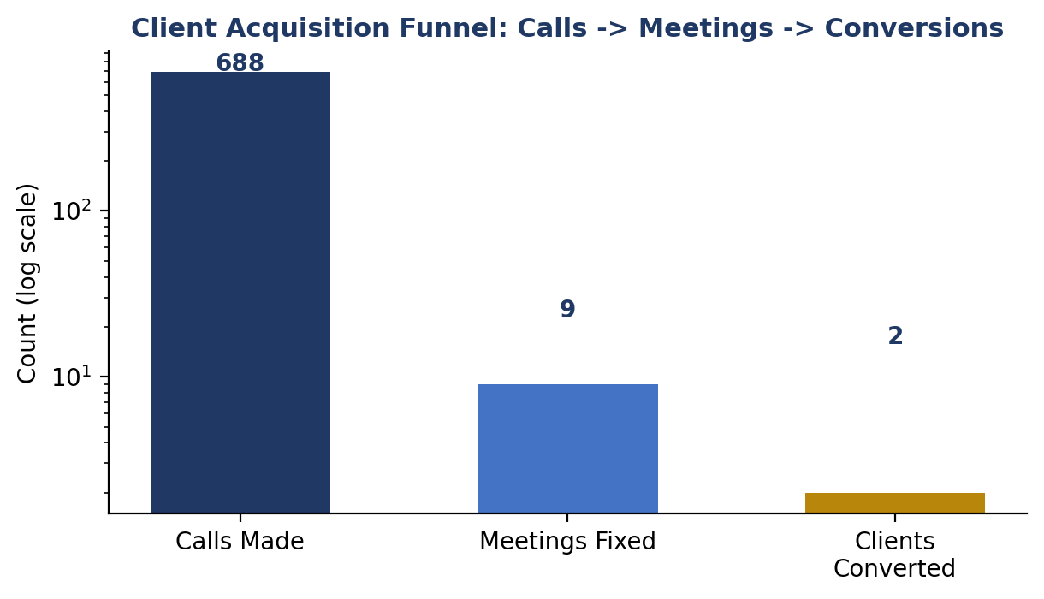
Figure 2: Funnel volumes on a log scale, illustrating the steep drop from calls to meetings

7.2 Week-wise Trend
Outreach volume was low in weeks 1-2 (training phase, no calling) and peaked in weeks 3-6 once field visits and cold calling were running in parallel, before tapering in the final week. Meetings fixed tracked outreach volume loosely rather than tightly - weeks with higher call volume did not always produce proportionally more meetings, suggesting lead quality (not just call volume) was a meaningful driver of meetings fixed.
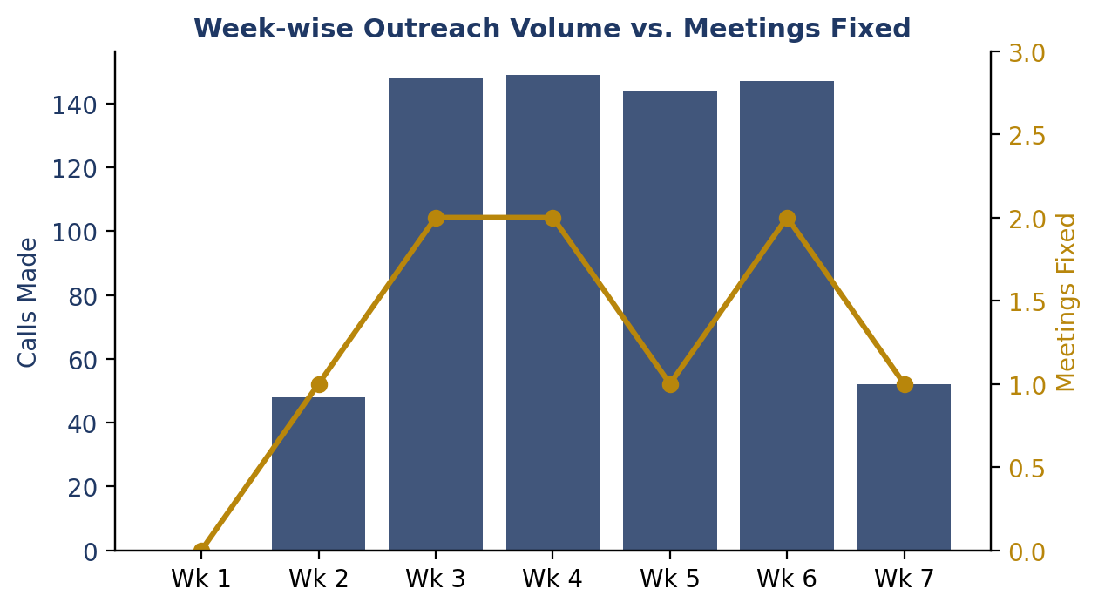
Figure 3: Weekly calls made (bars) vs. meetings fixed (line)

7.3 Field Visits vs. Cold Calling as Channels
Field visits produced 2 same-day meetings across 15 days (a 13% same-visit meeting rate), while cold calling produced 7 meetings across 688 calls (roughly 1 meeting per 98 calls). Read together, this suggests field visits are a higher-intent, lower-volume channel - useful for identifying warm leads on the spot - while cold calling is a high-volume, low-hit-rate channel best used to convert a pre-qualified list rather than a cold, unfiltered one.

7.4 Retail Investor Behaviour & Objections
- Reachability was the single biggest drag on cold-calling productivity - remarks across multiple days note prospects as "mostly not reachable," pointing to a need for better call-time targeting (e.g., lunch hours, early evening) rather than more raw dialing.
- When prospects did engage, the most common next step was a request for more information via email rather than an immediate meeting - indicating a trust/verification step retail investors want before committing time to a meeting.
- SIP-led pitches (especially Equity and ELSS tax-saving SIPs) appeared to generate more follow-through than insurance-led pitches, plausibly because SIP has a clearer, more immediate value proposition (compounding, tax saving) for a first-time conversation.

7.5 Investment Preferences Observed
Both confirmed conversions during the internship were into SIP - Equity Fund, consistent with the broader pattern that equity-oriented SIPs were the easiest product to get a prospect to act on in a single sales cycle, versus insurance (typically a longer decision cycle) or debt/hybrid SIPs (a harder value proposition to communicate briefly on a cold call).

7.6 Client Segmentation
Leads were effectively segmented by location/employer type (corporate office parks vs. commercial/business hubs) rather than by formal demographic or income criteria. This is a reasonable proxy for a short internship, but Section 9 recommends a more deliberate segmentation approach going forward.

7.7 Confirmed Conversions
# | Client | Organisation | Product | Date Converted | Status
1 | Anita Verma | XYZ Corp | SIP - Equity Fund | 10-07-2026 | Converted
2 | Suresh Kumar | PQR Ltd | SIP - Equity Fund | 15-07-2026 | Converted
Table 3: Clients converted during the internship period

7.8 Challenges in Acquisition
- Low reachability on first call attempts, requiring repeated follow-up on the same lead list.
- Security/access restrictions at a small number of office locations limiting field-visit coverage.
- Long decision cycles for insurance products relative to the internship's short duration.
- No CRM system was used during this internship; all activity was tracked manually in a day-wise log, which limited the ability to segment or re-target leads systematically.

8. Key Learnings

8.1 Technical Learning
Gained working knowledge of SIP mechanics and compounding, mutual fund category differences (equity, debt, hybrid, ELSS) and their risk-return trade-offs, and the comparative structure of term, ULIP, and endowment insurance plans across three insurers. Also built a basic understanding of equity market infrastructure - indices, demat and trading accounts - sufficient to hold an informed first conversation with a prospect.

8.2 Financial Learning
Learned to translate product features into a client-relevant pitch - for example, framing an ELSS SIP around Section 80C tax saving alongside long-term growth, rather than purely as a mutual fund category. Also observed, first-hand, how fee/commission-based distribution economics shape which products a wealth management firm is incentivised to prioritise in conversations.

8.3 Sales & Relationship Management
The internship reinforced that acquisition is a persistence game more than a pitch-quality game: the same lead often required two to three follow-up attempts before a conversation happened at all, and objection handling (especially around reachability and "send me details first") mattered more than product knowledge once a prospect was actually on the call.

8.4 Client Communication
Learned to keep a first-contact pitch short and product-specific rather than a broad company introduction, and to close every call with a clear, low-friction next step (a scheduled callback or meeting) rather than leaving follow-up open-ended.

8.5 Wealth Management Process
Developed a practical, end-to-end view of how a wealth management branch converts unstructured outreach into an advisory relationship - from risk profiling through to product recommendation - and how acquisition activity (calls, meetings) is tracked and reviewed by a reporting manager on an ongoing basis.

9. Recommendations
The following recommendations are grounded in patterns observed during this internship and are intended as practical, low-cost process improvements for the branch's client acquisition activity:

9.1 Improve Call Reachability
- Shift a larger share of cold-calling attempts to lunch-hour (1-2 PM) and early-evening (6-7 PM) windows, where working professionals are more likely to answer, based on the "mostly not reachable" pattern seen on several days.
- Introduce a simple 2-attempt-then-reschedule rule so unreachable leads are not abandoned after a single attempt but are also not over-called.

9.2 Pre-Qualify Leads Before Cold Calling
- Use field-visit conversations to capture a one-line intent signal (e.g., "interested in tax-saving," "just wants brochure") so cold-calling follow-up can be prioritised toward higher-intent leads first, rather than calling the full list in the order collected.

9.3 Lead a First Conversation with SIP, Not Insurance
- Given that both confirmed conversions and stronger engagement came from SIP-led (particularly Equity and ELSS) conversations, structure the first-contact pitch around SIP, and introduce insurance as a secondary conversation once trust is established.

9.4 Adopt a Lightweight CRM
- Even a simple shared spreadsheet or low-cost CRM tool to log lead status, last-contacted date, and next follow-up date would materially improve on the current manual day-wise log, and would let the branch systematically re-target leads that went cold rather than losing track of them.

9.5 Formalise Location-Based Segmentation
- Track meeting and conversion rates by location type (corporate office park vs. commercial hub) over a longer period than one internship cycle, to identify which locations consistently produce better-quality leads and deserve repeat visits.

9.6 Build a Short Email/WhatsApp Follow-up Asset
- Since several prospects asked for details via email before committing to a meeting, having a ready one-page product explainer (per product: SIP-Equity, SIP-ELSS, term insurance) to send immediately after a call would reduce drop-off between "interested" and "meeting fixed."

10. Conclusion
This internship provided direct, practical exposure to the full client acquisition and investment advisory cycle at Anand Rathi Wealth Management's Indore branch - from foundational product training through field-based lead generation, outbound cold calling, and advisory conversations, culminating in 2 confirmed client conversions and a pipeline of follow-up leads. The 688 calls and 15 field visits completed over the internship generated a realistic, first-hand view of what retail client acquisition looks like on the ground: a high-volume, moderate-reachability, persistence-driven process where meeting quality matters more than call quantity.
Beyond the measurable activity, the internship built a working understanding of SIP, mutual fund, and insurance products; sharpened client communication and objection-handling skills; and produced a set of concrete, low-cost recommendations (Section 9) that the branch could apply to future acquisition drives. On a personal and professional level, the internship strengthened both technical financial-product knowledge and practical sales/relationship-management skills, and offered a realistic sense of what a career in retail wealth advisory involves day to day.

11. Appendix

11.1 Client Acquisition Workflow
- Step 1 - Training: Complete product & risk-profiling training (SIP, MF, Insurance, Equity basics).
- Step 2 - Field Visit: Visit a corporate office / business hub; introduce SIP & Insurance; collect contact details.
- Step 3 - Lead Logging: Record leads with location, contact details, and any intent signal noted.
- Step 4 - Cold Calling: Follow up on leads within the same week; pitch product; attempt to fix a meeting.
- Step 5 - Advisory Conversation: For fixed meetings, apply risk-profiling before recommending a specific product.
- Step 6 - Conversion / Follow-up: Close as converted, or schedule next follow-up; update daily log and share with reporting manager.

11.2 Internship Summary Statistics
Metric | Value
Total Calendar Days | 46
Total Off Days | 9
Total Training Days | 8
Total Field Visit Days | 15
Total Cold Calling Days | 14
Total Calls Made | 688
Total Meetings Fixed | 9
Total Clients Converted | 2
Table 4: Summary statistics for the full internship period (4 June - 19 July 2026)

